

Emotions Wordsearch!

|  |  |  |  |  |  |  |  |  |  |  |  |  |  |  |
| --- | --- | --- | --- | --- | --- | --- | --- | --- | --- | --- | --- | --- | --- | --- |
| D | Z | O | B | Q | K | T | D | E | I | S | D | I | S | A |
| M | F | A | Y | V | E | E | M | Z | S | I | V | V | N | E |
| S | N | H | W | A | T | M | I | I | S | B | L | G | O | N |
| U | E | H | L | I | T | D | D | A | F | N | R | G | L | O |
| O | I | W | C | E | B | Q | P | J | E | Y | B | B | E | S |
| L | V | X | D | C | F | P | D | E | S | S | E | R | T | S |
| A | E | G | D | E | O | T | Z | M | T | U | K | F | Y | F |
| E | J | X | I | I | S | W | O | F | E | S | K | J | Z | I |
| J | N | Q | N | Q | I | U | A | U | R | O | Z | B | S | G |
| N | R | T | J | C | B | K | F | R | T | R | A | R | J | M |
| U | E | D | Y | A | R | I | C | N | P | R | T | Y | F | P |
| D | Z | R | W | M | D | H | E | F | O | Y | F | I | F | Y |
| Y | T | Q | W | R | Y | U | K | K | C | C | T | N | F | P |
| Y | K | O | U | Q | J | P | F | N | E | R | V | O | U | S |
| D | Z | R | N | U | L | F | H | O | H | U | Q | P | D | K |



Use the words to fill in the gaps below and then find them in the Wordsearch.

It’s tricky – the words might be backwards or diagonal so try your best!



* You have been waiting for ages for school lunch and then someone pushes in front of you in the queue. You might feel

a _ _ _ _

* You’ve been looking forward to Golden Time all week. But then someone misbehaves so your teacher says the class will be doing handwriting instead. You might feel d _ _ _ _ _ _ _ _ _ _ _ _
* You just got piles of homework over the weekend but you don’t think you’re going to have time to do it. You might feel s _ _ _ _ _ _ _
* Your teacher has set you a maths task but you are not sure what to do. You might feel c _ _ _ _ _ _ _
* Tomorrow you are speaking in your class assembly. You might feel n _ _ _ _ _ _
* Your friends have all gone off at playtime and you are alone. You might feel l _ _ _ o _ _
* It’s your birthday tomorrow! You might feel e _ _ _ _ _ _
* Someone in your class has got the coolest new trainers and everyone loves them. You might feel j _ _ _ _ _ _
* 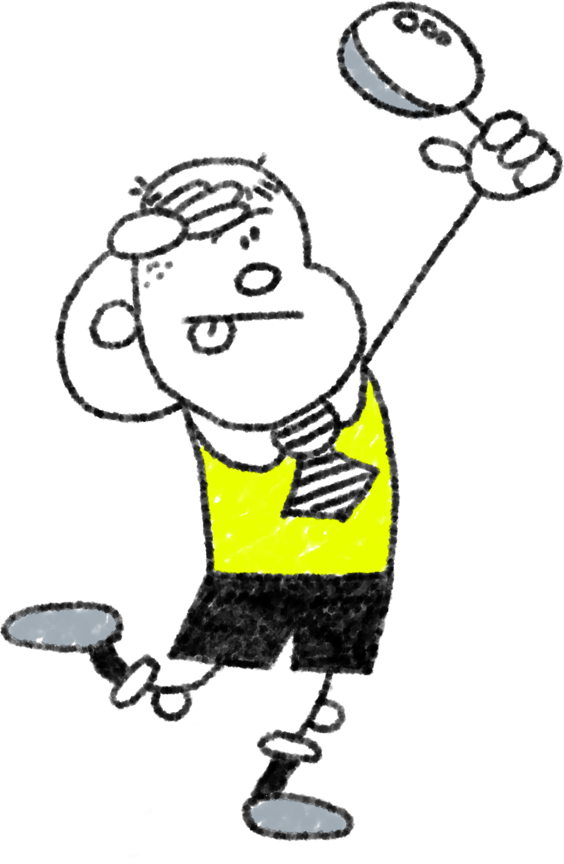By accident, you knocked into someone and they fell over and hurt themselves. You might feel s _ _ _ _

Sorry

Jealous

Confused

Nervous

Excited

Disappointed

Left-out

Stressed

Angry